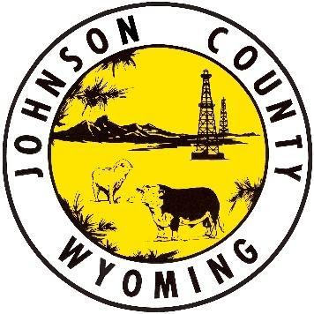
Johnson County Emergency Operations Center
Official Statement
8/7/20 4:00 pm

CONTACT TRACING RELATED TO THE CITY POOL IS COMPLETED
Johnson County Public Health has completed the contact tracing in relation to the city pool with assistance from the Wyoming Department of Health Epidemiology. If you were not contacted by a public health official, your risk for contracting COVID19 were found to be low. Those identified as a high exposure risk have been quarantined. For anyone who ever feels that they have had a higher risk of exposure to COVID19, we ask you to self-quarantine for 14 days past last exposure, practice social distancing, avoid high risk individuals, and monitor yourself for symptoms of COVID19. If symptoms do arise, contact our local testing facilities for testing.
You can find the Public Health Guidance for Community-Related Exposure by the CDC at the link below:
https://www.cdc.gov/coronavirus/2019-ncov/php/public-health-recommendations.html
Please continue to be vigilant and practice all appropriate hygiene and distancing recommendations, including wearing a face covering when you cannot avoid being within 6 feet of others.
Johnson County COVID-19 Numbers
Active Cases: 1
Lab Confirmed: 18
Probable: 4
Recovered: 21
Deaths: 1

____________________________________________________________________________

For the most current information, please visit www.johnsoncountywyoming.org/covid-19.
There has been a COVID-19 response email set up for Johnson County: jcwycovid19eoc@gmail.com.
For further questions, contact the Johnson County Emergency Operations Center: 307-425-6560.

