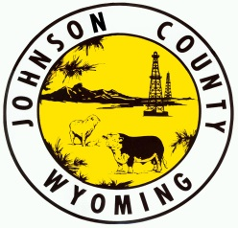
Johnson County Planning & Zoning Commission
26 North DeSmet Street, Buffalo, Wyoming 82834

Phone: (307) 684-1907 ⋅ e-mail: jwaller@johnsoncowy.us

Regular Meeting
Tuesday, June 14, 2022 5:30 pm

Agenda

5:30 pm Call meeting to order

Business

Presentation of Kolb Minor Final Plat & Boundary Line Adjustment; Final Review (Rock Creek Rd/Kolb Dr)
Adjourn

6/8/2022

