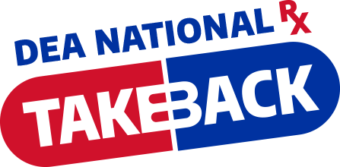
Prescription Drug Take Back Program
SATURDAY, April 27; NOON - 2pm

Bring unused, unwanted or outdated prescription medications to:
Ace Hardware
There is NO paperwork! This process takes only a minute.

The following items will not be accepted:

- Needles & Sharps
- Mercury (thermometers)
- Oxygen containers
- Chemotherapy medicines
- Radioactive substances
- Pressurized canisters
- Liquids & Creams

